DZS Global Services and Support (GSS)
HealthCheck Report for I3
OLT: 172.16.114.24

Prepared for: CUSTOMER
Position
Company
Address
Contact Details

Prepared by: DZS Employee
Position
Global Services & Support
Company
Address
Contact Details

Date: Date
Table of Contents
1.0 Executive Summary 3
2.0 Overview 4
3.0 System summary 5
4.0 card summary 6
5.0 port summary 7
6.0 Log & Alarm analysis 8
7.0 Stats and KPI analysis 9
8.0 ONT analysis 10
9.0 Final analysis and next steps 11

1.0 Executive Summary
- Need to provide an overall summary of this doc and purpose and what was done
- Provide executive summary of the health check..similar to below slide, but in graphs (pie-chart or something).
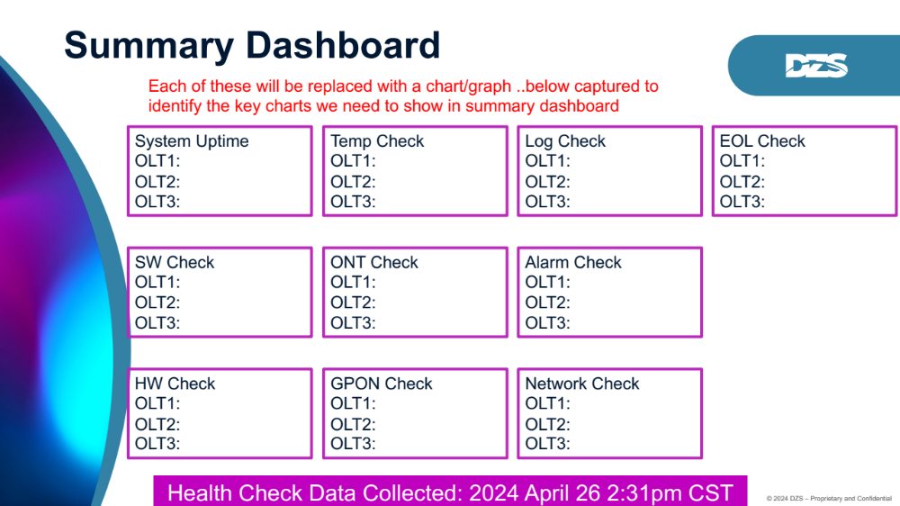

2.0 Overview
- Overview of the OLT chassis etc
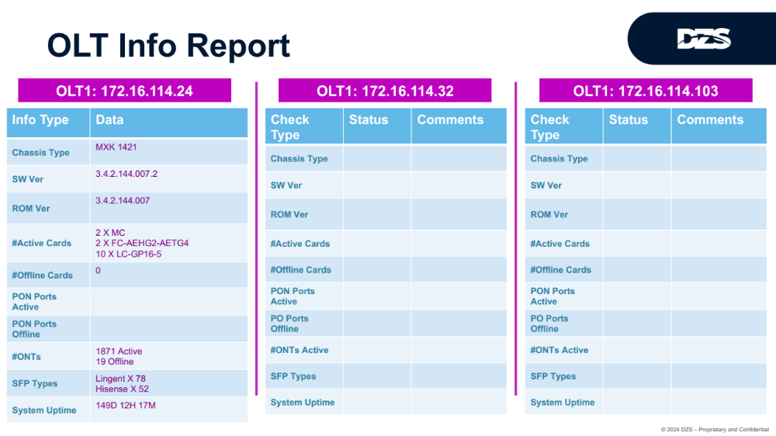

3.0 System summary

- OLT info details, system info, security info, customer settings, port access list etc
  - Using xcard linkagg
  - SNMP community name set so SNMP is being used. Check for excessive SNMP walks.

- Minor/major warnings etc.:
  - ‘alarm show’ output shows that the ‘AlarmTotalCount’ is more than 170k. Viewing the ‘log cache’ output for frequently recurring alarms resulted in the following comments:
    - Most of the alarms posted in the log cache are related to several ONU’s that are toggling continuously between being discovered, then ‘no longer present’, rediscovered, ‘no longer present’, etc. This is resulting in the ‘GPON Olt Onu Error alarm’ being continuously set and cleared. The reason for this may be related to the ‘rx power out of range’ or ‘rx power out of range, rx power too low.’ alarms that are posted in the ‘alarm show’ output for these ONU’s. It is recommended that the reason for 'rx power out of range’ should be investigated for the following ONU’s:
      - 1/3/9/7/gpononu
      - 1/4/15/18/gpononu
      - 1/10/11/5/ gpononu

  - Several ONU ports are reporting either ‘rx power out of range’ or ‘rx power out of range, rx power too low.’ and should be investigated (see output of ‘onu status’ command). The ONU’s with rx power issues are:
    - 1-1-6-19/gpononu
    - 1-2-1-4/gpononu
    - 1-2-6-18/gpononu
    - 1-2-8-4/gpononu
    - 1-2-12-10/gpononu
    - 1-4-3-1/gpononu
    - 1-7-8-11/gpononu
    - 1-7-15-2/gpononu
    - 1-8-5-12/gpononu
    - 1-10-11-14/gpononu
- ‘bip threshold exceeded’ is being reported for 1-2-12-10/gpononu. The fiber should be checked for physical issues.
- Fans/Power/Battery info
  - Fans OK - All fans only running at 65%
  - Temp Sensor 15 has an asterisk meaning it is higher than the threshold

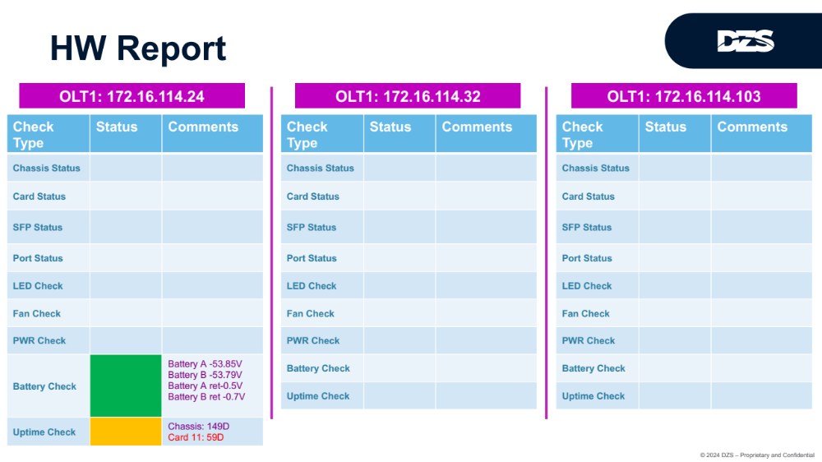

4.0 card summary

- list of the cards, SFPs, what is bad, version data etc
- Any EOL situations?

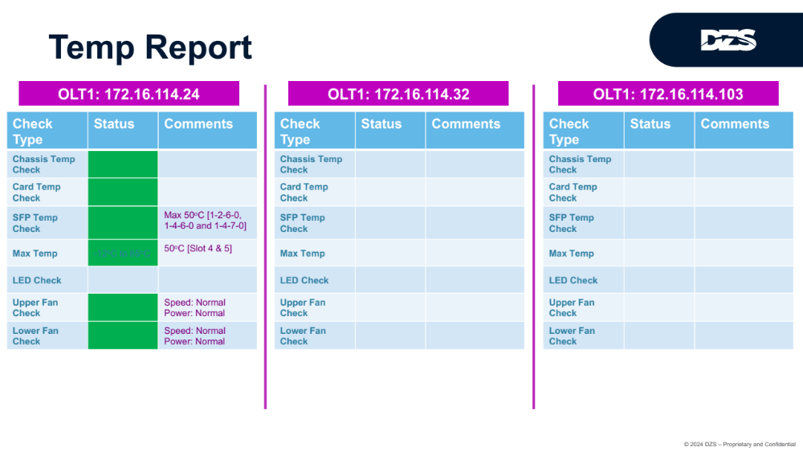

5.0 port summary
- Provide ethernet/port level info, what is bad, what are the issues etc
- SPF related info if it makes sense here
- Non-DZS SPF items, issues etc
- Any EOL situations?

6.0 Log & Alarm analysis

- Look at logs and alarms and provide analysis on issues identified, active alarms etc
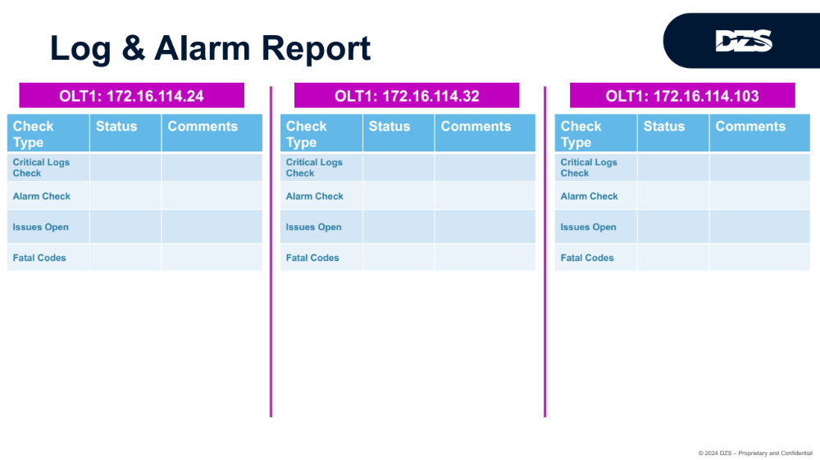

7.0 Stats and KPI analysis
- Look at the error counters/stats etc and identify issues
- Look at error counters on all active ONTs etc
- Make an educated analysis based on what we see

8.0 ONT analysis

- Look at ONT SW versions…do they need to be upgraded?
- Look into any ONT that requires uprgrades or re-provisioning etc

9.0 Final analysis and next steps

- Summary final thoughts and next steps

